*NAMES: Marc NDAYISABA*

*REG No: 21rp02083*

*CLASS: EAT;B*

*Title;* ***AUTOMATIC ZEBRA CROSSING WITH SPEED BREAKER***

***ABSTRACT*;**As our teclogy advances, the use of robots and other autonomous applications in our daily lives increases as well.Automation technology comprises all processes and work equipment that enable plants and systems to run automatically. These include machines, apparatus, equipment and other devices. Human intervention is minimal.

*keywod*: Arduino, servo motar and ultrasonic sensors

***CHAPTER I:INTRODUCTION***

Automation technology is a key industry on the path towards Industry 4.0. The term stands for intelligent, digitally interconnected systems that enable largely independent industrial production. In a smart factory, humans, plants, products and logistics are interconnected through communication channels, an approach which is sometimes seen as a fourth industrial revolution.

The engineering discipline takes a multidisciplinary approach and encompasses both mechanical and electrical engineering. The aim of automation is to enable plants and machinery to automatically perform work processes efficiently and at a low error rate. Various levels of automation can be achieved, depending on the complexity of the systems involved. The higher the degree of automation, the less intervention needs to be performed by humans to control the process. In order to further the performance of your systems, it is important to develop the capability of your central components. Harmonic Drive AG is your competent partner when it comes to high-class drive solutions for controlling automation equipment.

***1.1 Back ground***

An automated system consists of a plant, a controller in the form of an automation computer, and peripheral devices. This environment is equipped with sensors that collect control data and actuators that perform controller commands. Interconnected fieldbus systems are a further element. They link the individual automation components together with the controller.

***1.2 problem ststement***

Automation systems have a variety of key functions, which include measuring and controlling. Additional system operations include regulating and communicating. The control room - the so-called human-machine-interface - is the technical facility from which all processes are monitored.

The individual automation technology subsystems contain several specialised components. Measurements are generally performed with the aid of sensors. They are able to detect and determine the prevailing physical and chemical conditions, such as humidity, pressure and heat. A distinction is made between passive and active sensors. A wide range of such detectors has been specially developed for automated systems.

Digital control of systems in the field of automation is performed using a flexible programmable logic controller (PLC). Control commands are transmitted to the system via actuators, such as motors, valves or magnets. Such systems used to contain permanently wired connection-programmed controllers, in which any changes to the programming necessitated modifying the connections. With a PLC system, it is sufficient simply to modify the program. This controller was developed in the USA in 1968 and was introduced to Europe in 1973.

Regulating consists of continually measuring the parameter in question and comparing it with a target value. If the measurement deviates from requirements, an adjustment is made. The procedure is controlled by computer.***so this sysytem will reduce the accident due to hihg speeed of vehicle in popular area espcialy in zebra crossing****.*

***1.3 OOBJECTIVES***

***1.3.1 General objectives***

The general objectives is to *reduce the accident due to hihg speeed of vehicle in popular area espcialy in zebra crossing.*

1.3.2 specific objectives

* to tell vehicle's drivers to pass zebra crossing with low speed by using speed breakers

* to remember every one in zebra crossing there is high risk

* vehicle and person can pass to gether

* due to event those speed breaker can turned off . example: high security is needed when hihgly grade leader passing

***CHAPTER II: ULTRASONIC SENSOR***

An ultrasonic sensor is an electronic device that measures the distance of a target object by emitting ultrasonic sound waves, and converts the reflected sound into an electrical signal. Ultrasonic waves travel faster than the speed of audible sound (i.e. the sound that humans can hear). Ultrasonic sensors have two main components: the transmitter (which emits the sound using piezoelectric crystals) and the receiver (which encounters the sound after it has travelled to and from the target).

­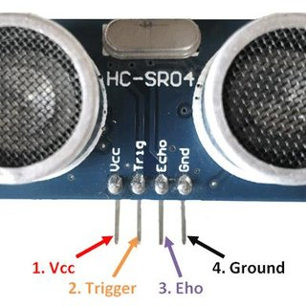***1.1 Figure***

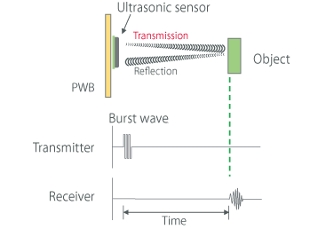

In order to calculate the distance between the sensor and the object, the sensor measures the time it takes between the emission of the sound by the transmitter to its contact with the receiver. The formula for this calculation is D = ½ T x C (where D is the distance, T is the time, and C is the speed of sound ~ 343 meters/second). For example, if a scientist set up an ultrasonic sensor aimed at a box and it took 0.025 seconds for the sound to bounce back, the distance between the ultrasonic sensor and the box would be :D = 0.5 x 0.025 x 343

An ultrasonic sensor emits sound waves toward an object and determines its distance by detecting reflected waves.

Ultrasonic sensors are used primarily as proximity sensors. They can be found in automobile self-parking technology and anti-collision safety systems. Ultrasonic sensors are also used in robotic obstacle detection systems, as well as manufacturing technology. In comparison to infrared (IR) sensors in proximity sensing applications, ultrasonic sensors are not as susceptible to interference of smoke, gas, and other airborne particles (though the physical components are still affected by variables such as heat).

Ultrasonic sensors are also used as level sensors to detect, monitor, and regulate liquid levels in closed containers (such as vats in chemical factories). Most notably, ultrasonic technology has enabled the medical industry to produce images of internal organs, identify tumors, and ensure the health of babies in the womb.

***More uses of Ultrasonic sensor:***

*Anti-Collision Detection.

*People Detection.

*Contouring or Profiling.

*Presence Detection.

*Box Sorting using a Multi-Transducer System.

*Easy Control of Trash Collection Vehicles.

*Pallet Detection with Forklifts.

*Bottle Counting on Drink Filling Machines.

***Advantages of Ultrasonic sensor***

Following are the advantages of Ultrasonic sensor:

➨It has sensing capability to sense all the material types.

➨This sensor is not affected due to atmospheric dust, rain, snow etc.

➨It can work in any adverse conditions.

➨It has higher sensing distance (in centimeters and inches) compare to inductive/capacitive proximity sensor types.

➨It provides good readings in sensing large sized objects with hard surfaces.

***Disadvantages of Ultrasonic sensor***

Following are the disadvantages of Ultrasonic sensor:

➨It is very sensitive to variation in the temperature.

➨It has more difficulties in reading reflections from soft, curved, thin and small objects.

***CHAPTER III: SERVO MOTAR***

As our teclogy advances, the use of robots and other autonomous applications in our daily lives increases as well. While cheaper robots use stepper or brushed DC motors, more advanced robotics require the use of servo motors. But what is a servo motor and why are they used in most industrial applications?

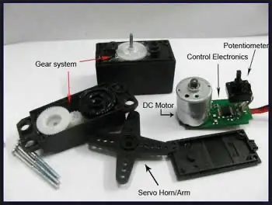

***1.2 Figure***

***3.1 Advantages Of Servo Motors***

Servo motors offer several advantages over other types of motors, including:

*Precision Control

*High Torque

*Fast Response Time.

*Wide Speed Range.onstruction of Servo Motor

3.2 ***construction of servo motor***

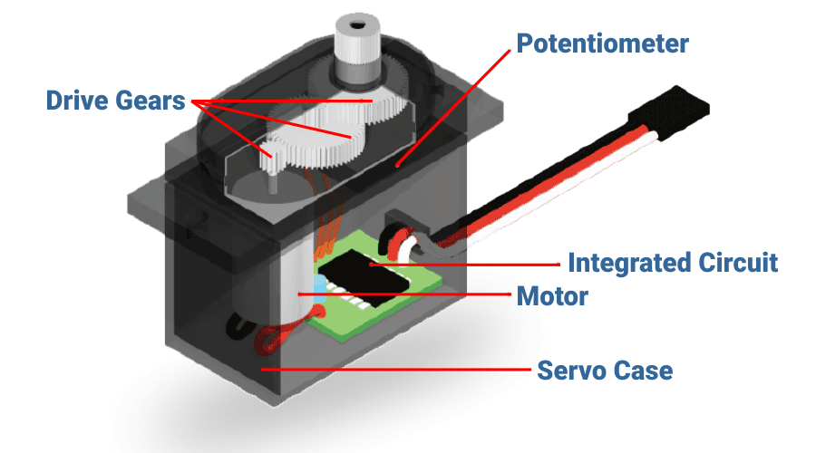

red wire= + positive

black wire= - negative

white wire= data

This motor is a closed-loop mechanism that incorporates positional feedback in order to control the rotational or linear speed and position.

***This motor is actually an assembly of four things:***

*Normal DC motor- That is in charge of generating the motion *through its shaft.

*Gear reduction unit/gear box

*Potentiometer

*Control circuit

The DC motor connects with a gear mechanism which provides feedback to a position sensor which is mostly a potentiometer.

It is connected to the central shaft, and informs at all times the angle in which the motor’s shaft is available

From the gear box or gear reduction unit, the output of the motor delivers via servo spline to the servo arm. the gear box is formed by gears which may increase or decrease the speed and torque.

The standard servo motor uses the plastic gear whereas the high power servo motor uses the metal gear.

A control circuit allows for control over the motor’s motion by sending electric pulses

Motor consists of three wires- a black wire connected to ground. A white/yellow wire connected to control unit. And a red wire connected to power supply

***3.2 Servo Motor Applications***

Servo motors are used in a wide range of industrial and commercial applications that require precise control of motion, including:

*Robotics.

*CNC Machines.

*Packaging Machinery

*Aerospace.

*Autonomous Guided Vehicles

*Medical Equipment

*Printing and Paper Processing

*Industrial Automation

***CHAPTER IV: Arduino***

Arduino UNO is a microcontroller board based on the ATmega328P. It has 14 digital input/output pins (of which 6 can be used as PWM outputs), 6 analog inputs, a 16 MHz ceramic resonator, a USB connection, a power jack, an ICSP header and a reset button.

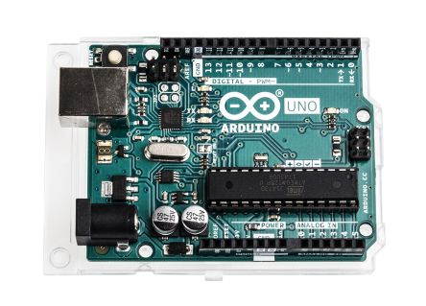

***1.3 Figure***

***4.1Features of Arduino Uno Board***

The operating voltage is 5V.

The recommended input voltage will range from 7v to 12V.

The input voltage ranges from 6v to 20V.

Digital input/output pins are 14.

Analog i/p pins are 6.

DC Current for each input/output pin is 40 mA.

DC Current for 3.3V Pin is 50 mA.

Flash Memory is 32 KB.

**AUTOMATIC ZEBRA CROSSING WITH SPEEDD BREEAKER**

***REQUIRED MATERIALS***

*Arduino uno board

*bread board

*ultrasonic sensor

*servo motar

*jumping wires

*buzzer

*battery(9v dc)

***Codes***

#include<servo.h>

servo my servo;

int pos=20;

const int trigpin=5;

const int echopin=6;

int buzzer=10;

long duration;

float distance;

void setup()

{

myservo.attach(11);

pinMode(trigpin,OUTPUT);

pinMode(echopin,INPUT);

pinMode(buzzer,OUTPUT);

myservo.write(pos);

}

void loop()

{

//serial.begin(9600);

digitalWrite(trigpin,LOW);

delay(1);

digitalWrite(trigpin,HIGH);

delay(1000);

digitalWrite(trigpin,LOW);

duration=pulseln(echopin,HIGH);

distance=0.034*(duration/2)

//serial.println(distance);

if(distance<10)

{

myservo.Write(pos+160);

digitalWrite(buzzer,HIGH);

delay(4000);

}

else

{

myservo.Write(pos);

digitalWrite (buzzer,LOW);

}

delay(1000);

}